Date: 03/09/2020

Author: Girish Gowda

**Model Based Development of Complex Driver Informatics**

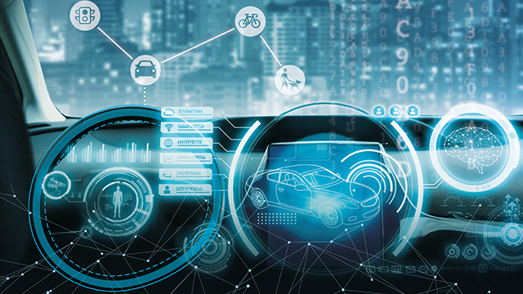

**Overview**

* Requirement Maturation and electronic specification Creation
* Model based development of Cluster components
* Verification of the functional behavior in accordance with the specifications

**Project details**

* Requirement analysis and maturation (Q&A)
* Guidelines for model creation and review checklist
* Control Model creation
* Unit and system level test plan creation and MIL testing
* Feedback to Design Team on specification defects
* Generated Auto code for SIL Test

**Value Addition**

* Migration to electronic specification from conventional ways (paper based)
* Working prototype to validate the functional behavior
* Defects detection in early stages of development cycle
* Auto-code generation
* End to End Requirements traceability

**Rapid Prototype for Concept Infotainment System**

* Model View Controller Architecture
* Development of Qt / Qml, Java script-based HMI Software as per the wireframes received from Design team.
* Designing Interface Layers for Input, Widget, Features, Devices and Hardware for parallel modules development across teams and flexible integration.
* Integration with C++ based controller algorithm.
* Development of Rhapsody based models for various features and auto code generation.
* Integration of Model (Features developed in Rhapsody), View (Qml, Java Script) and Controller (C++) and creating final executable for various platforms (Windows, Linux, Qnx etc).

